EMBEDUR NETWORKING ASSIGNMENT-2
MODULE 3 & 4

G ADITHYA PRASAD

QUE1:

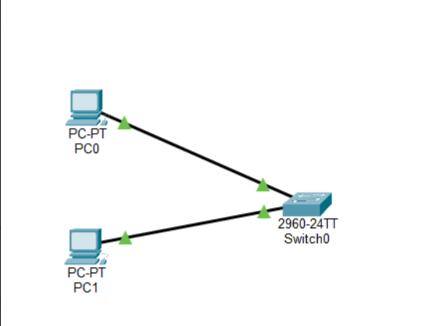

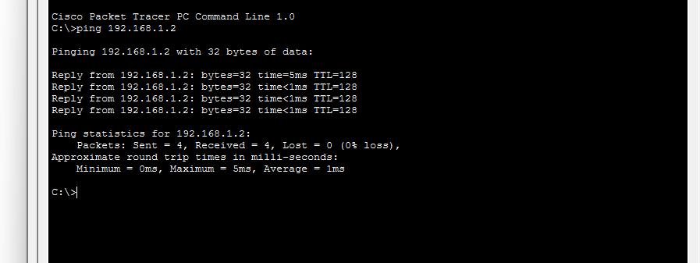

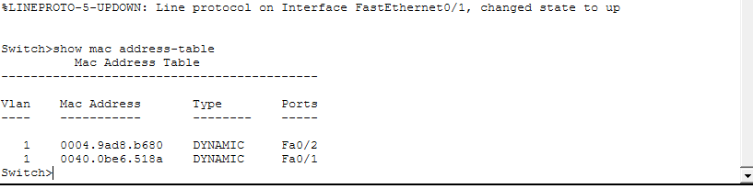
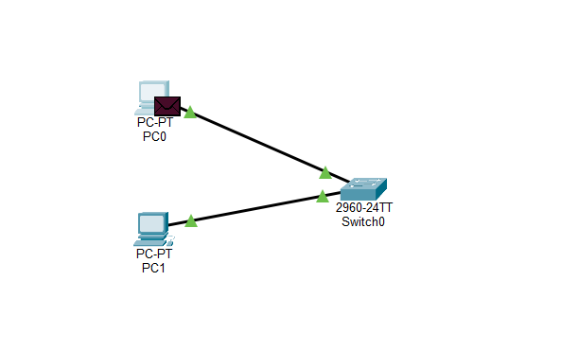
Instead of packets instantly finishing like in realtime mode, you will see small colored envelopes moving between devices.
Those envelopes represent Ethernet frames.
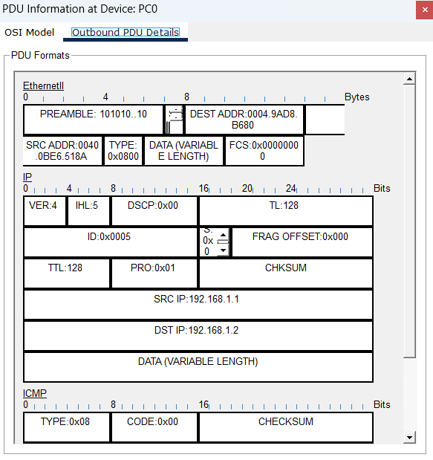
THIS IS THE ETHERNET FRAME STRUCTURE. TO GET THIS INFORMATION WE NEED TO CLICK ON THE PDU(PACKET).

QUE2:
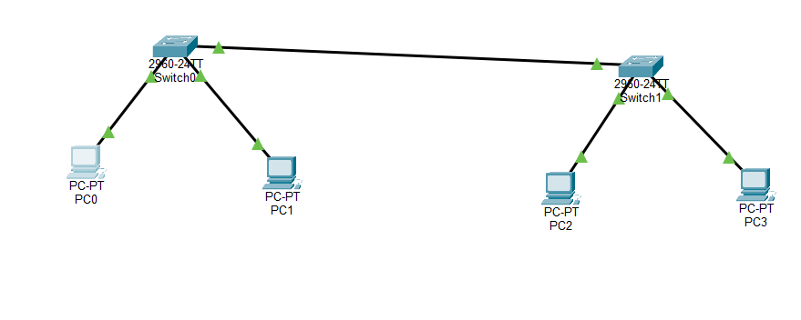

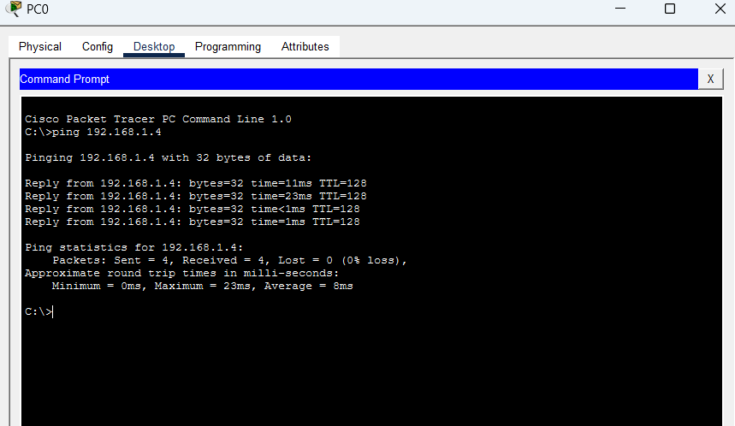

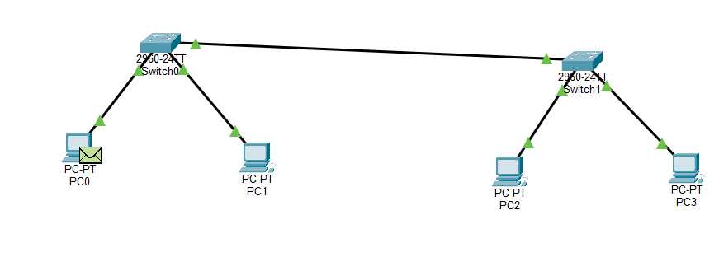
THE ABOVE INDICATES, AFTER NETWORK TRAFFIC CREATION
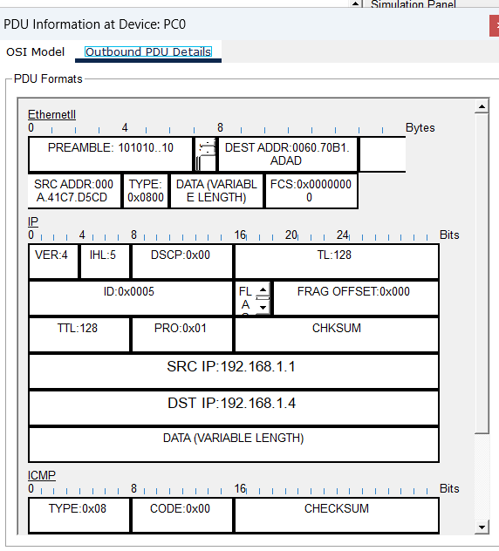

NOW DOING THE SAME WITH WIRESHARK , WHERE WE USE ping 8.8.8.8 to generate traffic in the command prompt and in wireshark we click the WIFI interface and search for ICMP inside it.

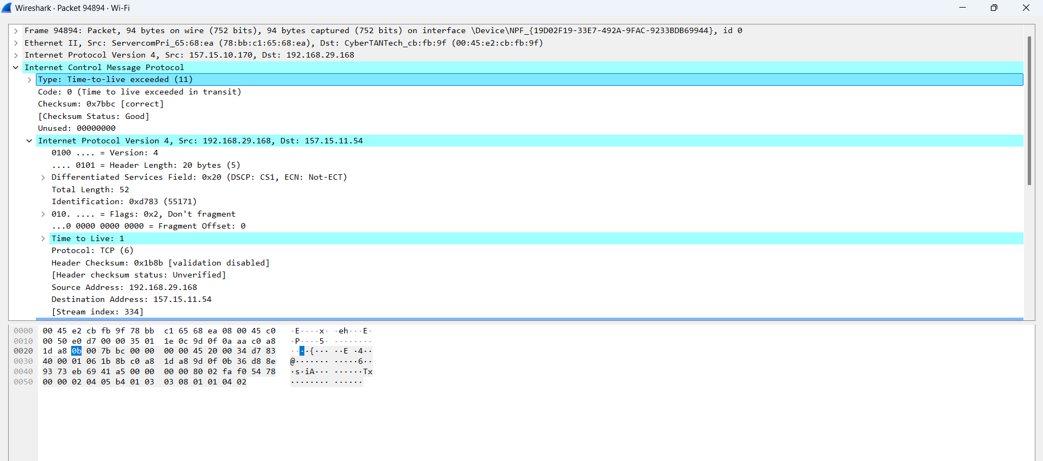

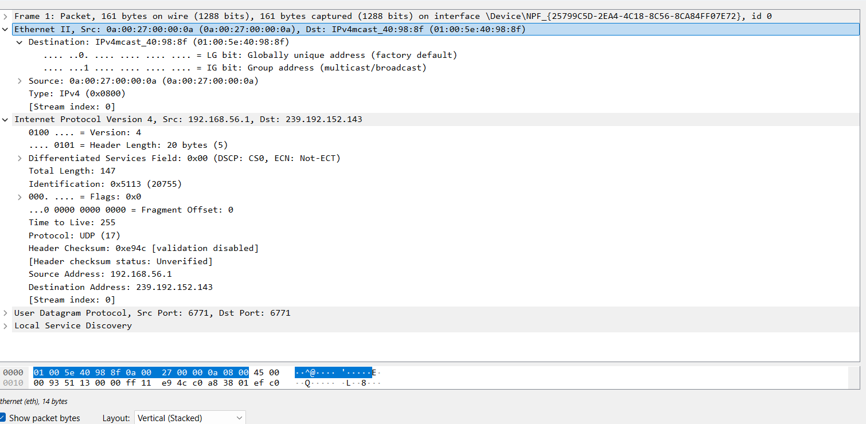

Destination MAC Address:
The destination MAC address identifies the device that receives the Ethernet frame. It can be found in the Ethernet II section of the packet details in Wireshark under the field Destination.
Example: Destination: 34:ab:37:12:9a:11
Source MAC Address:
The source MAC address identifies the device that sent the Ethernet frame. It is located in the Ethernet II header in Wireshark under the field Source.
Example: Source: 40:1c:83:8f:21:5a
EtherType:
The EtherType field indicates the protocol encapsulated inside the Ethernet frame. It is found in the Ethernet II header in Wireshark under the field Type.
Example: Type: IPv4 (0x0800)
Payload:
The payload contains the actual data carried inside the Ethernet frame. It can be observed in Wireshark by expanding Internet Protocol Version 4 and Internet Control Message Protocol sections.
Example: ICMP Echo Request or ICMP Echo Reply
Frame Check Sequence (FCS):
The Frame Check Sequence is used to detect errors in the transmitted Ethernet frame. It is located at the end of the Ethernet frame, though it may not always be visible in Wireshark due to hardware filtering.

Que3: . Configure static IP addresses, modify MAC addresses, and verify network connectivity using ping and ifconfig commands.

Step - 1: Create a Simple Network with 3 interfaces and a Switch with Mininet:
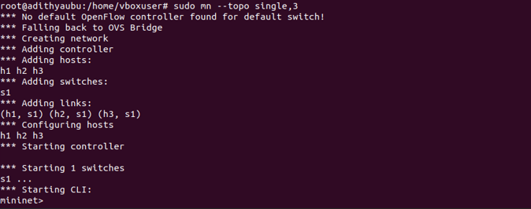
Step - 2: Configure Static IPs to the Interfaces H1 and H2:

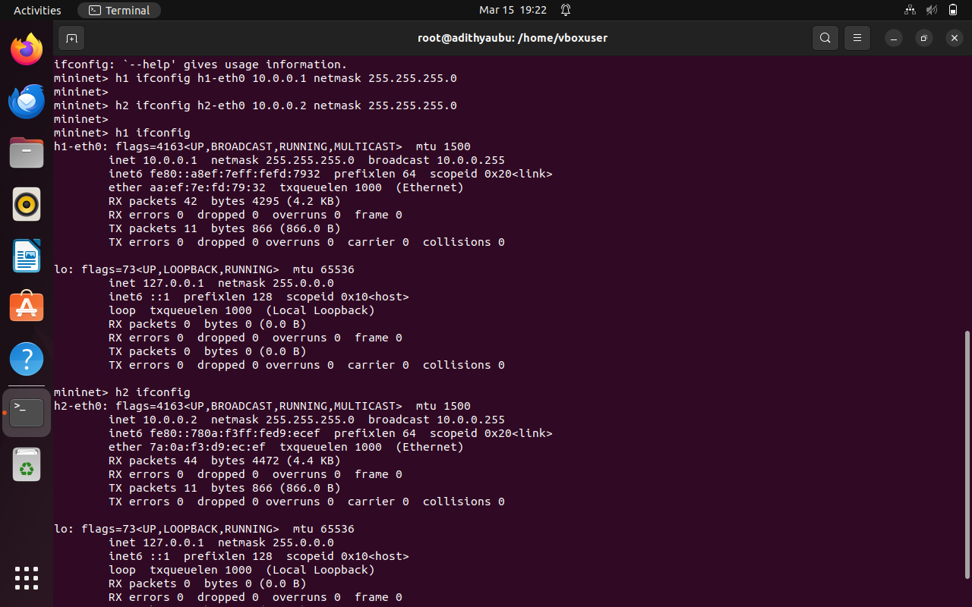

Step - 3: Modify the MAC Addresses:

Initial MAC of H1:
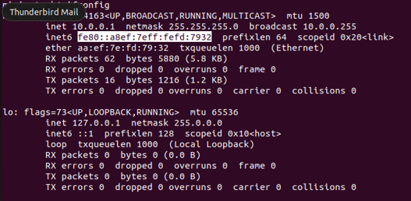
Bringing the interface down
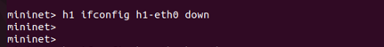
Edit the MAC Address and bring the interface Back up again :

H1 with new MAC Address:
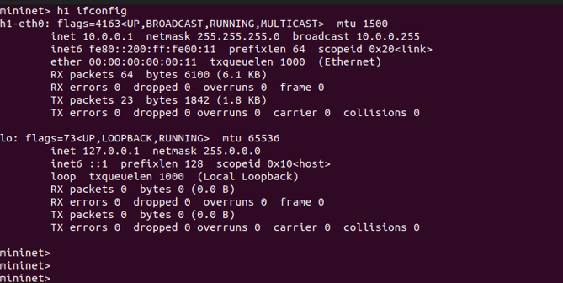

PING Test :
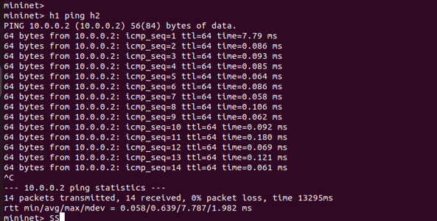

Que4: Troubleshoot Ethernet Communication with ping and traceroute -> Using cisco packet tracer
. Create a simple LAN setup with two Linux machines connected via a switch.
. If it fails, use ifconfig to ensure the IP addresses are configured correctly.
. Use traceroute to identify where the packets are being dropped if the ping fails.
Solution:

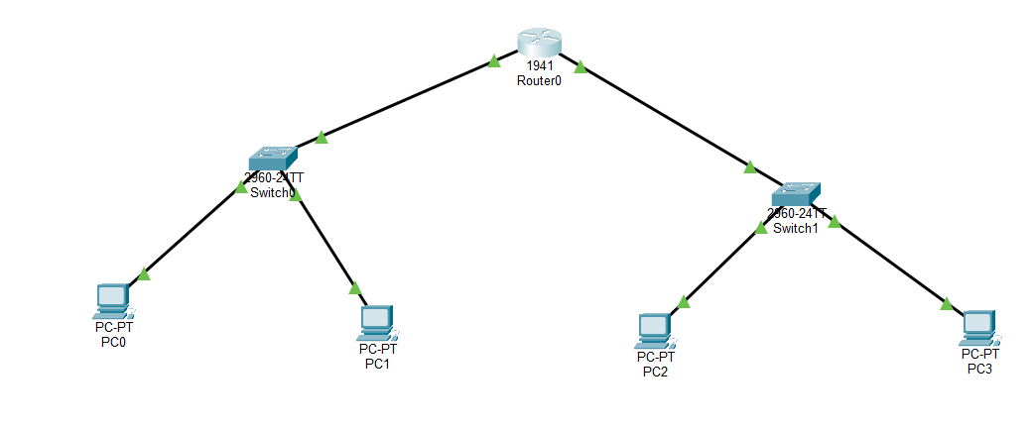
Step 1: Activate and Configure the Router
When a router is first placed in Packet Tracer, its interfaces are usually disabled. You must enable them and assign IP addresses so the router can connect the two networks.
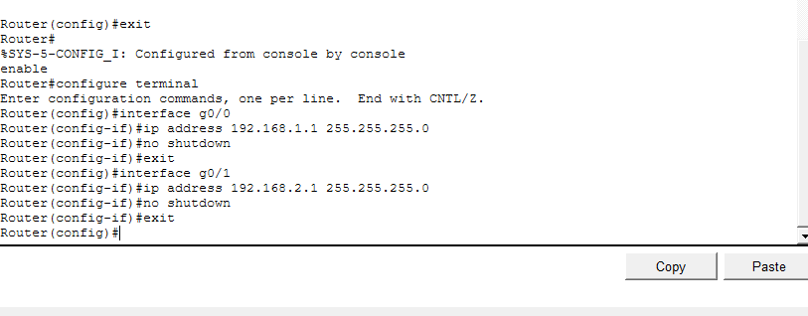

Step 2: Configure the IP Address of PC0
IP Address: 192.168.1.2
Subnet Mask: 255.255.255.0
Default Gateway: 192.168.1.1
The gateway is the router interface connected to Switch0.
Step 3: Configure the IP Address of PC1

IP Address: 192.168.1.3
Subnet Mask: 255.255.255.0
Default Gateway: 192.168.1.1
Now both PC0 and PC1 are in the same network.
Step 4: Configure the IP Address of PC2
IP Address: 192.168.2.2
Subnet Mask: 255.255.255.0
Default Gateway: 192.168.2.1
Step 5: Configure the IP Address of PC3
IP Address: 192.168.2.3
Subnet Mask: 255.255.255.0
Default Gateway: 192.168.2.1
Now PC2 and PC3 belong to Network 2.

Step 6: Test Communication Using Ping
Checking from PC0:
First test communication with another PC on the same switch. (192.168.1.3)
Next test communication across the router to some other PC. (192.168.2.2)
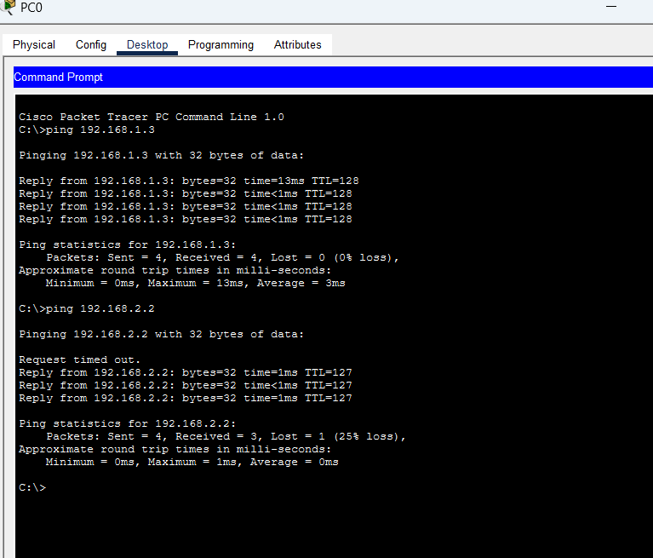

Now, for a FAILURE CASE:
Go to PC2 and change the IP address to something incorrect (192.168.3.2)
Now return to PC0 Command Prompt and run the ping command again.
ping 192.168.3.2
The output will display Request timed out, indicating that communication has failed.

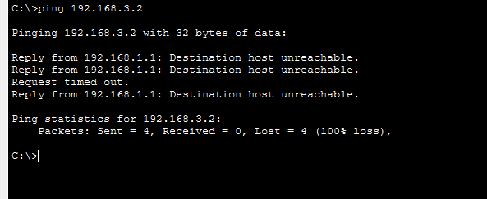

Check Configuration Using ifconfig , In case of linux system we would have used ifconfig command, but in CPT, we go to the respective pc and change the ip configuration of the pc into correct IP Address.
USING TRACEROUTE,
Now from PC0 Command Prompt, run:
tracert 192.168.2.3
The output will show the packet path:
1 192.168.1.1
2 192.168.2.3
- Hop 1 → Router
- Hop 2 → Destination PC
If the router interface were down, the packets would stop at the router, helping identify where the communication failed.
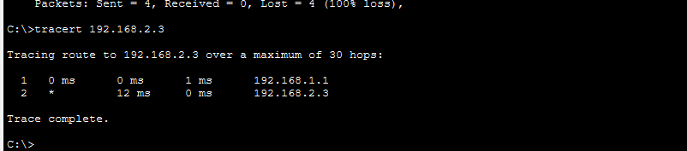

QUE 5: Research the Linux kernel's handling of Ethernet devices and network interfaces. Write a short report on how the Linux kernel supports Ethernet communication (referencing kernel.org documentation).

Linux Kernel Handling of Ethernet Devices and Network Interfaces
The Linux kernel provides a comprehensive networking subsystem that manages Ethernet devices and network interfaces. This subsystem enables communication between hardware network interface cards (NICs), kernel networking protocols, and user applications.
Linux Networking Subsystem
The Linux kernel networking architecture is implemented mainly in the net/ and drivers/net/ directories of the kernel source tree. The net/ directory contains the core networking protocols such as TCP/IP, while drivers/net/ contains hardware-specific network drivers. Development and maintenance of these networking components are coordinated through the netdev subsystem.
Network Device Representation
In the Linux kernel, each network interface is represented using the struct net_device data structure. This structure stores important information about the network device, including the interface name (for example, eth0), the MAC address, the Maximum Transmission Unit (MTU), device state and flags, and pointers to driver operations.
The kernel dynamically allocates and manages these structures using functions such as alloc_netdev(), and releases them using free_netdev() when the device is no longer required.
Ethernet Device Drivers
Ethernet communication in Linux relies on device drivers that interact directly with the network hardware. These drivers are responsible for initializing the network interface card, handling packet transmission and reception, managing interrupts and DMA buffers, and providing statistics and configuration interfaces.
A wide range of drivers exist to support different hardware manufacturers, including Intel and Mellanox network adapters. All these drivers are integrated within the Linux kernel networking framework to ensure consistent communication between hardware and the networking stack.
Packet Processing
When an Ethernet frame arrives at the system, several steps occur within the Linux networking stack.
First, the network interface card receives the frame from the physical medium. The device driver then transfers the packet to the kernel networking stack. Inside the kernel, the packet is processed using the sk_buff (socket buffer) data structure, which represents network packets within the kernel.
The packet is then passed to higher-level protocols such as IP, TCP, or UDP for further processing. Similarly, when transmitting data, packets are generated by higher-layer protocols, passed through the networking stack, and delivered to the NIC driver, which transmits them onto the network.
Communication with User Space
The Linux kernel provides mechanisms such as Netlink sockets to allow communication between kernel networking components and user-space tools. These mechanisms enable administrative tools to configure and monitor networking parameters.
For example, utilities such as the ip command from the iproute2 suite allow administrators to configure network interfaces, manage routing tables, and control other networking features directly from user space.

QUE 6: Describe how you would configure a basic LAN interface using the ip command in Linux (kernel.org).
Configuring a Basic LAN Interface Using the ip Command in Linux
The ip command in Linux is part of the iproute2 package and is used to configure network interfaces, routing tables, and IP addresses. It replaces older commands such as ifconfig and route. Using the ip command, a system administrator can configure a basic LAN interface for communication within a network.
Step 1: View Available Network Interfaces
The first step is to identify the available network interfaces in the system. This can be done using the following command:
ip link show
This command displays all network interfaces present in the system, such as eth0, enp0s3, or wlan0, along with their status and MAC addresses.
Step 2: Enable the Interface
Before configuring the interface, it must be activated so that it can send and receive network packets. This is done using the following command:
sudo ip link set dev eth0 up
This command brings the network interface eth0 to an active state.
Step 3: Assign an IP Address
Next, a static IP address is assigned to the interface so that the system can communicate within the local network.
sudo ip addr add 192.168.1.10/24 dev eth0
This command assigns the IP address 192.168.1.10 with a subnet prefix /24, which corresponds to the subnet mask 255.255.255.0.
Step 4: Configure the Default Gateway
To allow communication with devices outside the local network, a default gateway must be configured.
sudo ip route add default via 192.168.1.1 dev eth0
This command sets 192.168.1.1 as the default gateway, enabling the system to send packets to external networks through the router.
Step 5: Verify the Configuration
After configuration, it is important to verify that the settings have been applied correctly. This can be done using the following command:
ip addr show eth0
This command displays the IP address and status of the interface. Connectivity can also be tested using the ping command.
ping 192.168.1.1
If replies are received, it confirms that the LAN interface has been successfully configured and can communicate with the gateway.

QUE 7: Use Linux to view the MAC address table of a switch (if using a Linux-based network switch). Use the bridge or ip link commands to inspect the MAC table and demonstrate a basic switch's operation.
SOLUTION:

Step 1 — Check what ports are inside the bridge
bridge link
If you see only:
enp0s3 master br0
→ Not enough to behave like a switch.
You need two ports in br0.

Step 2 — Create a second virtual interface (no VirtualBox change needed)
We’ll create a virtual Ethernet pair (veth) inside Linux. This acts like two cables.
Create veth pair:
sudo ip link add veth0 type veth peer name veth1
Bring them up:
sudo ip link set veth0 up
sudo ip link set veth1 up

Step 3 — Add them to your existing bridge
sudo ip link set veth0 master br0
sudo ip link set enp0s3 master br0
Check:
bridge link
Now bridge has two ports:
- enp0s3
- veth0

Step 4 — Generate traffic through the bridge
Assign IPs to simulate two hosts on the bridge:
sudo ip addr add 10.0.0.1/24 dev veth1
sudo ip addr add 10.0.0.2/24 dev enp0s3
Ping:
ping 10.0.0.1

Step 5 — View MAC table (what you need)
bridge fdb show

